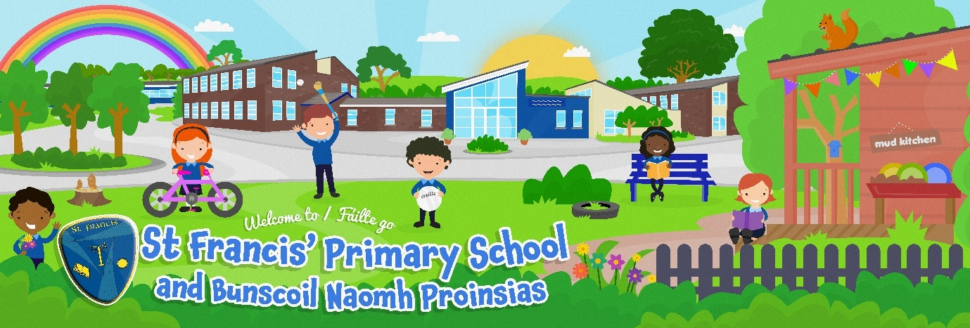

Dear Parents / Guardians,

We are delighted that your child will be starting Nursery with us in September 2023 and we look forward to meeting both you and your child.

Please save the following dates to start your child’s transition from home to Nursery.

Wednesday 24th May at 7pm
Introductory Meeting in the main school hall. This meeting is for parents / guardians only.

Open Day 5th June
At the Introductory Meeting you will be given a time between 9.30am and 3pm to bring your child to the Nursery to visit for half an hour.

Visit your classroom and meet your teacher & assistant
Monday 19th June
Within a week of the Open Day, you will receive a text with the name of your child’s teacher and a time to bring them to their classroom between 9.30am and 3pm for half an hour.

We look forward to seeing you soon,

The Nursery Team

